Camp Information Form (Scout Version)
Dates | Sat 21st & Sun 22nd Oct 2023
Event: | 1st Bedhampton Cubs and Scout Camp
Location: | Hampshire Cottage (aka Ruperts Farm), South Harting. map and directions are provided (map overpage)
Meeting place and time: | Hampshire Cottage (aka Ruperts Farm), 10am Sat 21st Oct 2023
Collection | Hampshire Cottage (aka Ruperts Farm), 3pm Sun 22nd Oct 2023
Cost: | £20 for the weekend (in advance please)
Transport details: | Please arrange own transport.
Activities: | We have decided to have a joint Cub and Scout Camp at “Ruperts” in South Harting. There will be lots of fun games with craft items to make and take home, in addition to Widegames, a Camp fire and hike to the top of Harting Down.  For the Scouts there is the option to go on a bike ride on the Saturday afternoon. We are doing Bike (& Car) Maintenance the Wednesday before camp. There will be alternative activities if you don’t have a bike or its not roadworthy. You must wear a helmet.  As always please feel free to speak to a leader of you have any concerns or worries.
Further details: | Over page
Organiser and contact details: | Nigel Vosper (07979736459). Alternatively contact Judy Colwell (07960479886)

Please keep this section for your own information, and detach and return the section below.
Note: All activities will be run in accordance with The Scout Association’s safety Rules. No responsibility for the personal equipment/clothing and effects can be accepted by the organisers and The Scout Association does not provide automatic insurance cover in respect to such items.

Please complete and return this section to section by 21st Oct 2023
Name of young person: |  |  | D.o.B:
Event: | 1st Bedhampton Cub and Scout Camp Oct 2023
I either a) enclose a cheque / cash for £20.00 b) Will do a Bank transfer for £20 or c) Will do a OSM (Gocardless) payment for £20
I have noted the arrangements above and agree to the named young person taking part. I understand that the event Leader reserves the right to send any participants home if deemed necessary.
Emergency contact: |  |  | Phone:
Doctor’s name and contact details: |  | Details of any medications currently being taken:
Details of any disabilities, conditions, allergies, special needs or cultural needs that might affect this event: |  | Details of any infectious diseases he/she has been in contact with in the last three weeks:
If it becomes necessary for the above named young person to receive medical treatment and I cannot be contacted to authorise this, I hereby give my general consent to any necessary medical treatment and authorise the Leader in charge to sign any document required by the hospital authorities.
Signed: |  | Date:
Relationship to young person:
Please use the back of this form if more space is required
Camp Kit List
All young people will need to bring their personal equipment and should be encouraged to pack themselves. This list is only a guide.
□ | Arrive in Uniform | □ | Sleeping bag and small pillow
□ | Warm sweaters, jumpers or sweatshirts (x2) | □ | Foam roll / karrimat
□ | T-shirts or similar | □ | Torch and spare batteries
□ | Trousers and shorts | □ | plastic drinks bottle/water bottle
□ | Spare underclothes | □ | Polythene bags (for dirty clothes)
□ | Spare socks | □ | Teddy!
□ | Warm Nightwear | □ | Tissues
□ | 2 pairs if trainers or hike boots or strong shoes | □ | Chair
□ | Waterproof | □ | Personal washing kit and towel
□ | Warm Coat | □ | Optional: Pen knife (handed in on arrival)
□ | Bike and Helmet (if going on bike ride)
- It is best to pack a rucksack or sports bag that you can carry on your back. Suitcases are not suitable..
- All items should be clearly labelled with the young person’s name.

Directions:
Directions : Take the A3(M) and continue on the A3 then take the slip road to Petersfield. There take the B2146 to South Harting. At the village turn left and immediate right towards East Harting. New Lane is the third turning on the right (and is labelled). Rupert’s farm is on the right at the end of the track.
Photo:
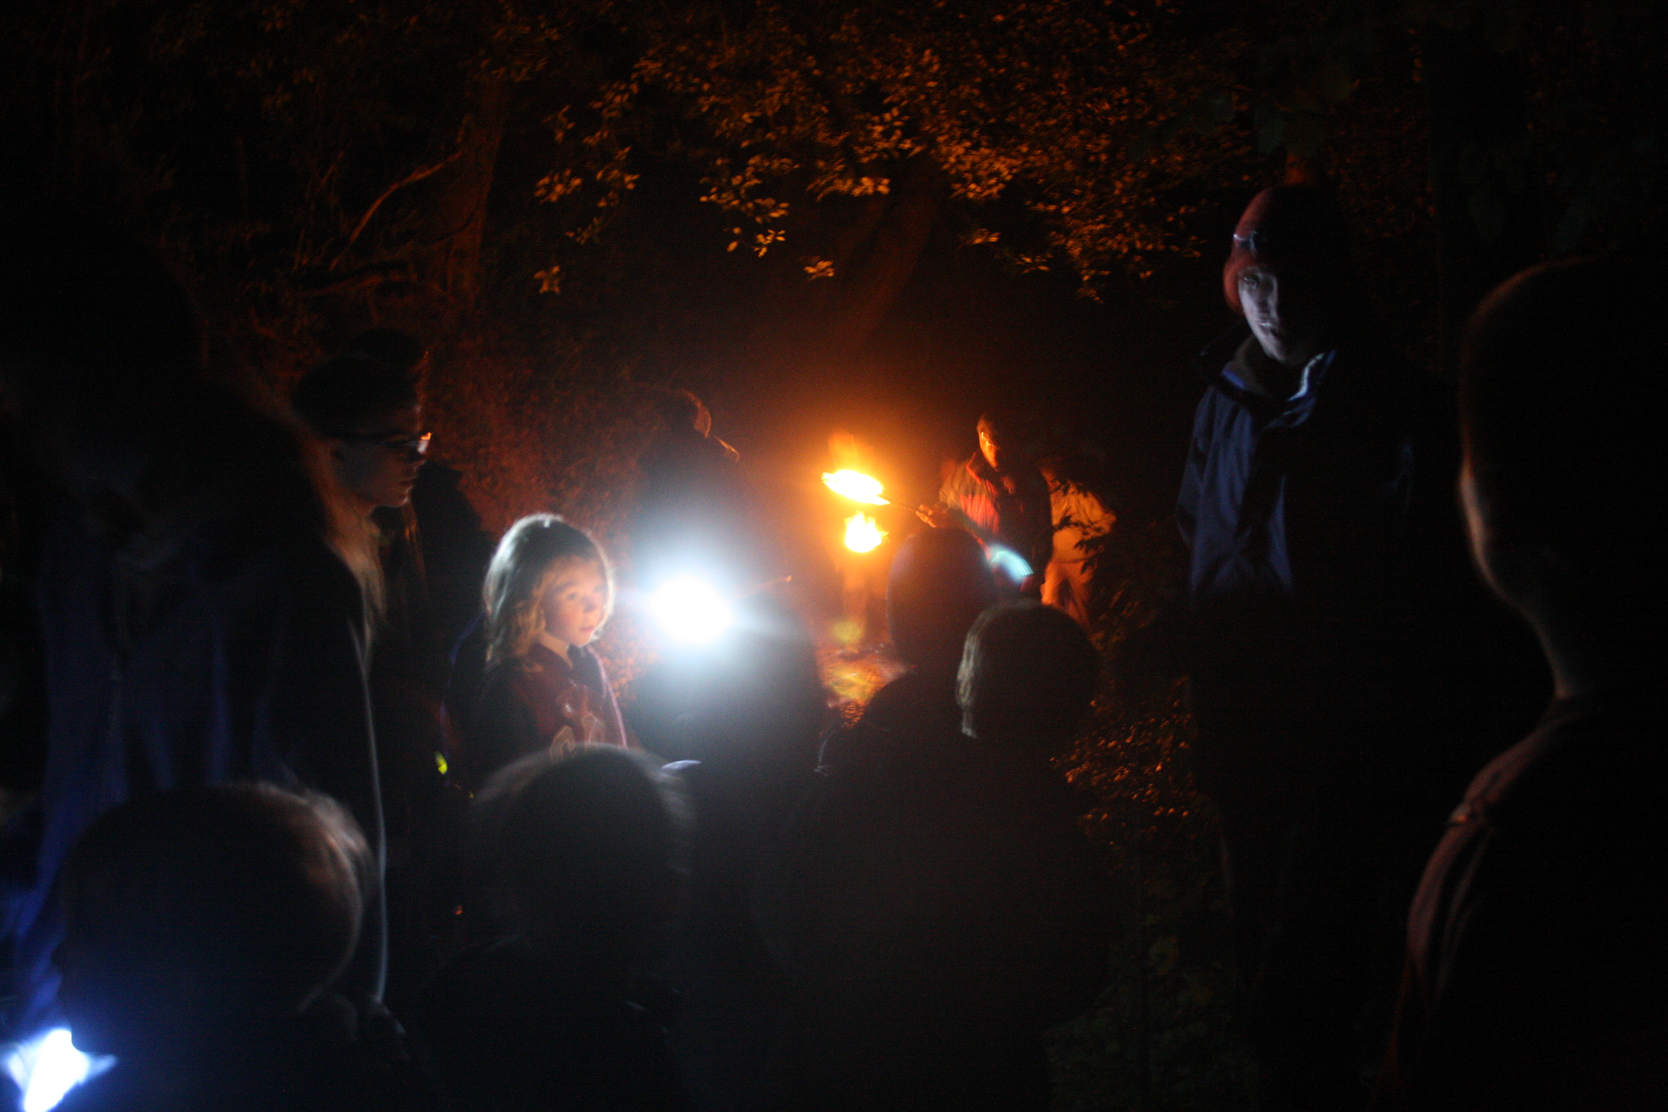
Above is a photo I took from a Group camp in Sept 13. It shows us walking the flaming “Spirit of Bedhampton torch” through the woods at night with Beavers, Cubs and Scouts! Adults held the flaming torches.

The older Scouts (+1 Cub) managed to walk it all the way to the top of Beacon Hill. We also did this at the last Group Camp in Apr 2015.
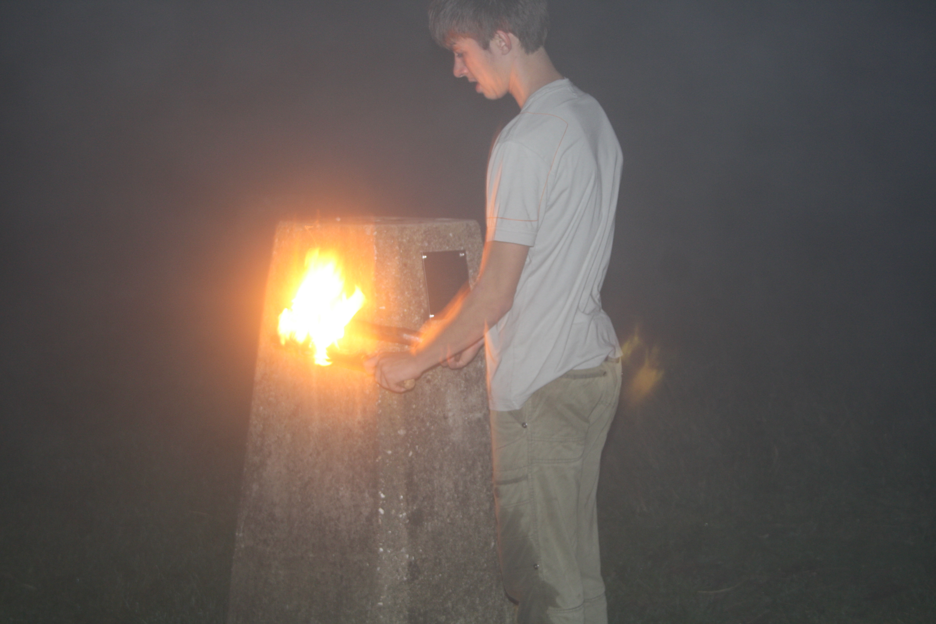

Before you reach the farm there will be a sign (or a perspon) to direct you to the car park. There is limited car parking spaces so if people can “drop and go” it would be appreciated.


